OPERATING SYSTEMS
WEEK-5 Practical
Name:- G.Sahasra
Roll no:- 2520030108
Section no:- 9
5Q.Implement a producer-consumer communication system using anonymous pipes where the parent process generates data and the child process consumes it. Measure the communication efficiency.
Develop a program that executes the equivalent of the shell command ls -l | grep ".c" using fork(), pipe(), dup2(), and exec() system calls.
Program:-
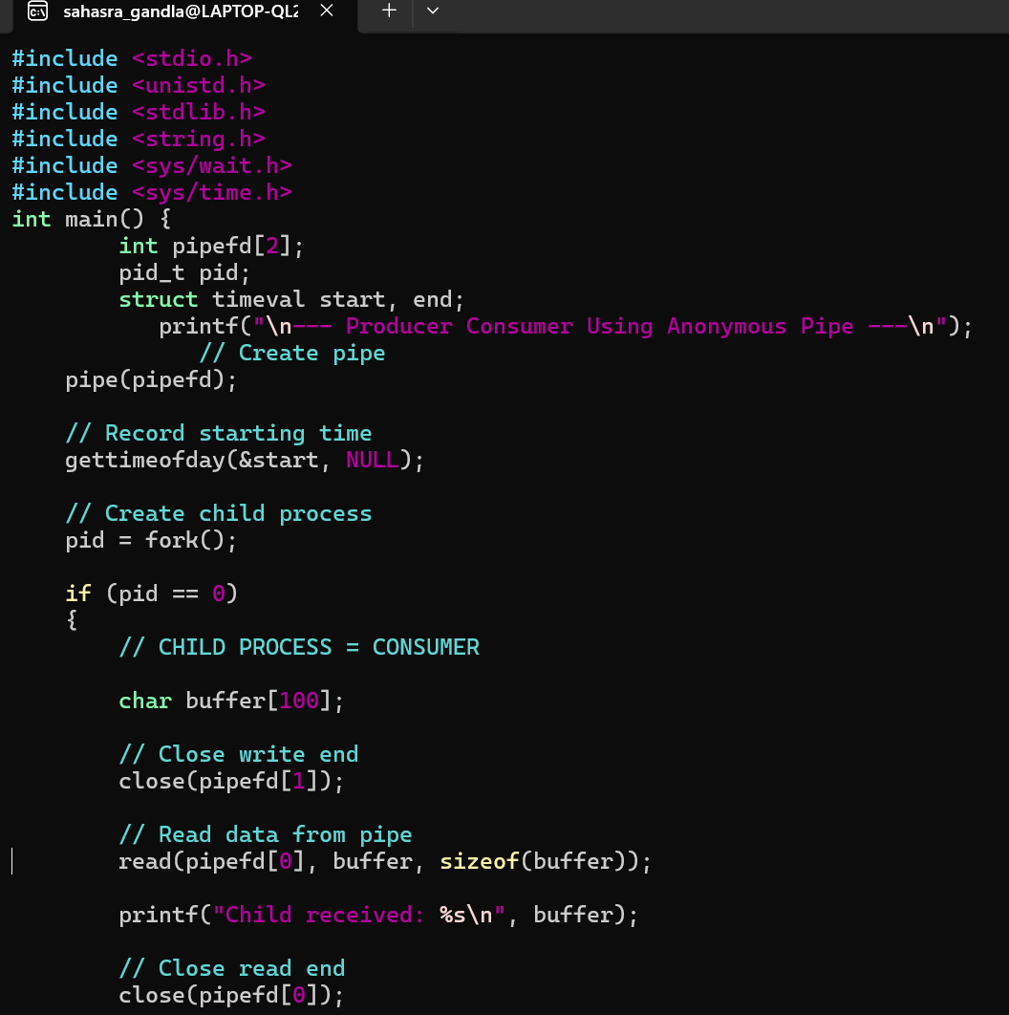
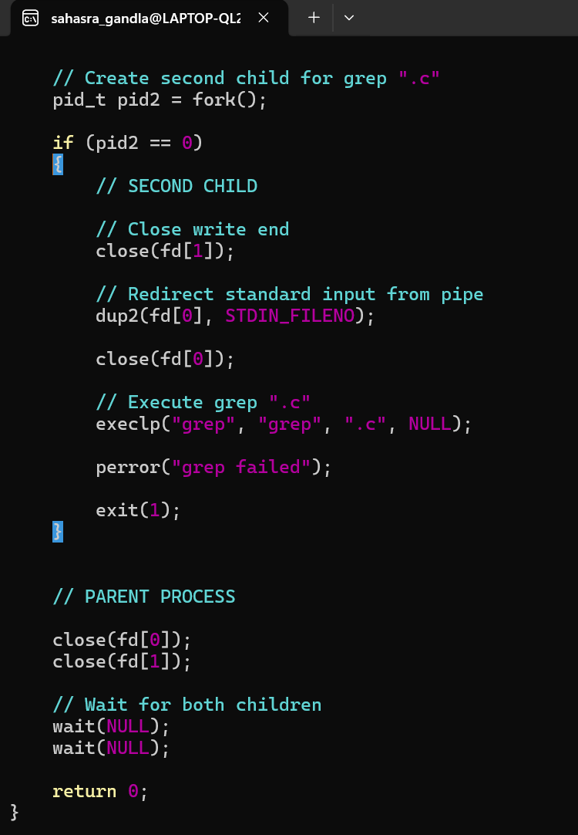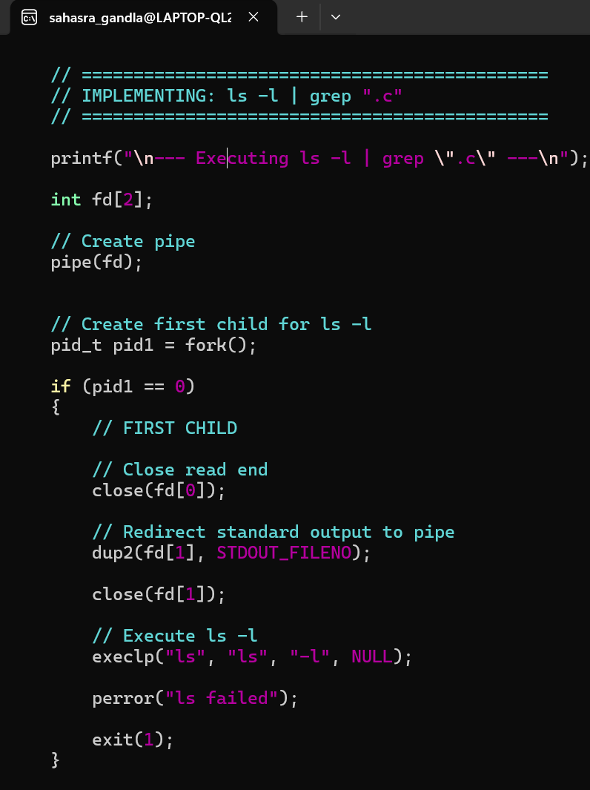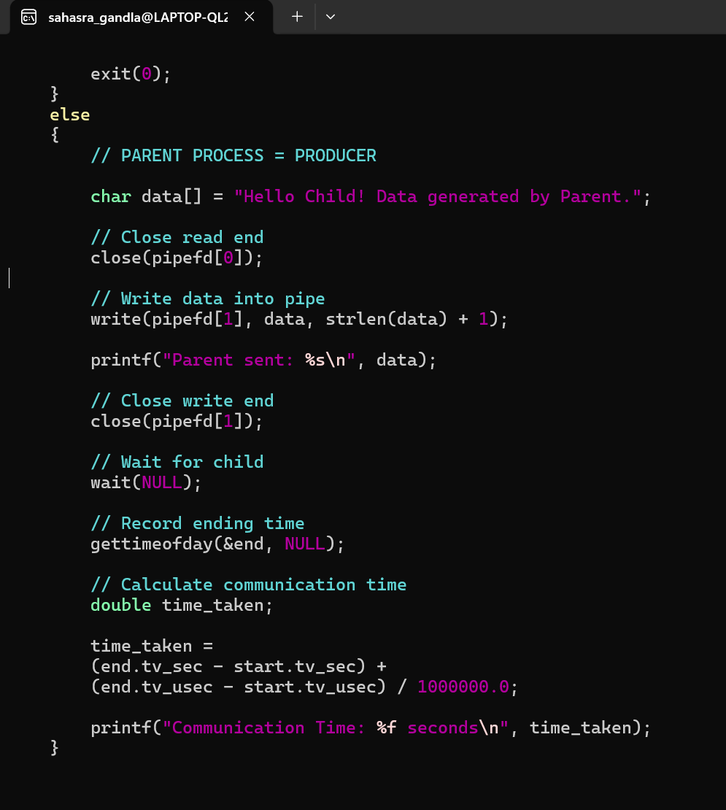

Output:- 